ANCIENT EGYPT: ASSIGNMENT
- Correctly label the cross section of the Nile River below. (5 marks)
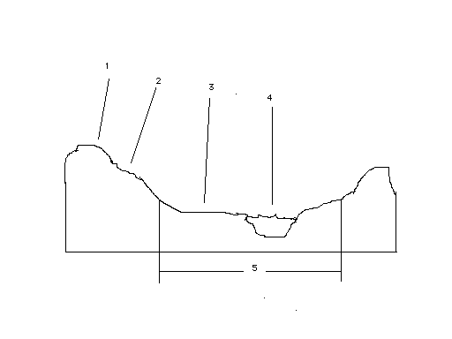
1. _______________________
2. _______________________
3. _______________________
4. _______________________
5. _______________________

- Explain the importance of the Nile River to the Ancient Egyptian civilisation. (10 marks) __________________________________________________________________________________________________________________________________________________________________________________________________________________________________________________________________________________________________________________________________________________________________________________________________________________________________________________________________________________________________________________________________________________________________________________________________________________________________________________________________________________________________________________________________________________________________________________________________________________________________________________________________________________________________________________________________________________________________________________________________

- Explain each of the three seasons and their importance to the Ancient Egyptian civilisation. (6 marks) __________________________________________________________________
________________________________________________________________________________________________________________________________________________________________________________________________________________________________________________________________________________________________________________________________________________________________________________________________________________________________________________________________________________________________________________________________________________________________________________________________________________

- List each of the social classes found in Ancient Egypt in order from highest rank to lowest. (5 ½ marks) ________________________________________________________________
____________________________________________________________________________________________________________________________________________________

- Explain the following social classes in detail. (16 marks)
a) Scribe: __________________________________________________________________
______________________________________________________________________________________________________________________________________________________________________________________________________________________________
b) Pharaoh: ________________________________________________________________
______________________________________________________________________________________________________________________________________________________________________________________________________________________________
c) Slave: ___________________________________________________________________
______________________________________________________________________________________________________________________________________________________________________________________________________________________________
d) Priest: __________________________________________________________________
______________________________________________________________________________________________________________________________________________________________________________________________________________________________

- Look at the Ancient Egyptian social customs listed below. In a well constructed short essay (about one page) discuss whether or not you think they are good/bad, appropriate for today and whether any still exist today. Also discuss why you think these customs might have developed. (25 marks)

- Early and arranged marriages.
- Large families.
- The Pharaohs and Nobles having more than one wife.
- While the wife shared her husband’s wealth, home and tomb, her role was seen as looking after the home and children.
- Children were expected to work on the fields and estates of their parents.
- Children from lower social classes and most girls did not attend school.
- Strong belief in horoscopes.
- Strong emphasis on manners, good behaviour and respect for one’s parents.
- Children were warned of the dangers of pride.
- The questioning of the ideas and beliefs of elders was frowned upon.

________________________________________________________________________________________________________________________________________________________________________________________________________________________________________________________________________________________________________________________________________________________________________________________________________________________________________________________________________________________________________________________________________________________________________________________________________________
________________________________________________________________________________________________________________________________________________________________________________________________________________________________________________________________________________________________________________________________________________________________________________________________________________________________________________________________________________________________________________________________________________________________________________________________________________
________________________________________________________________________________________________________________________________________________________________________________________________________________________________________________________________________________________________________________________________________________________________________________________________________________________________________________________________________________________________________________________________________________________________________________________________________________
________________________________________________________________________________________________________________________________________________________________________________________________________________________________________________________________________________________________________________________________________________________________________________________________________________________________________________________________________________________________________________________________________________________________________________________________________________

- Explain what is meant by the word archaeology. (2 ½ marks)
__________________________________________________________________________________________________________________________________________________________________________________________________________________________________________________________________________________________________________________________________________________________________________________

- What was the importance of archaeology in expanding our knowledge of Ancient Egypt? Give examples to help explain your answer.(10 marks)
__________________________________________________________________________________________________________________________________________________________________________________________________________________________________________________________________________________________________________________________________________________________________________________________________________________________________________________________________________________________________________________________________________________________________________________________________________________________________________________________________________________________________________________________________________________________________________________________________________________________________________________________________________________________________________________________________________________________________________________________________________________________________________________________________________________________________________________________________________________________________________________________________________________________________________________________________________________________________________

